# **Metro College Barrier Removal Instructions**

### How to determine if you have metro college barriers

1. Login to your MyMC page using your GEMS ID# and birth date.

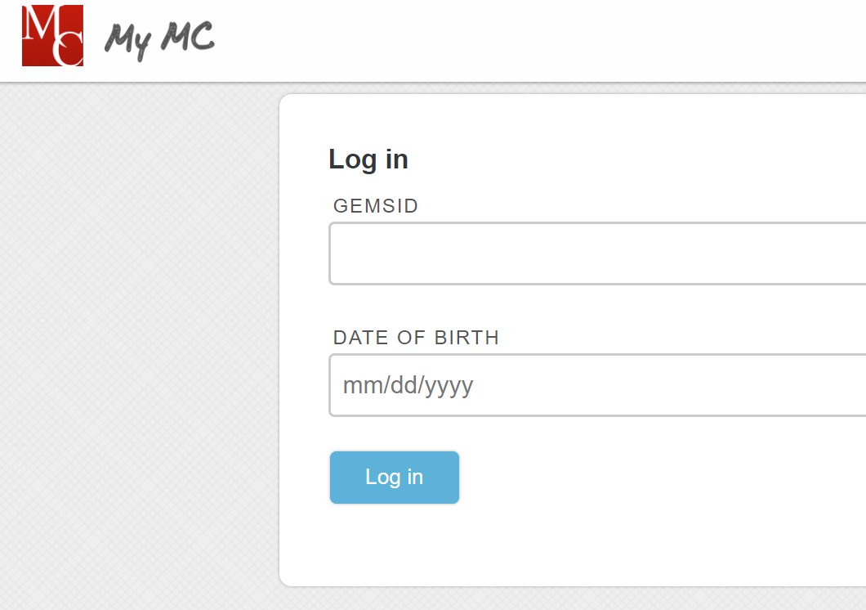

1. At the top of your screen look for an indicator to see if you have a barrier or not.
2. If your box color is **“Blue”** you are in good standing to sign for the next upcoming semester.

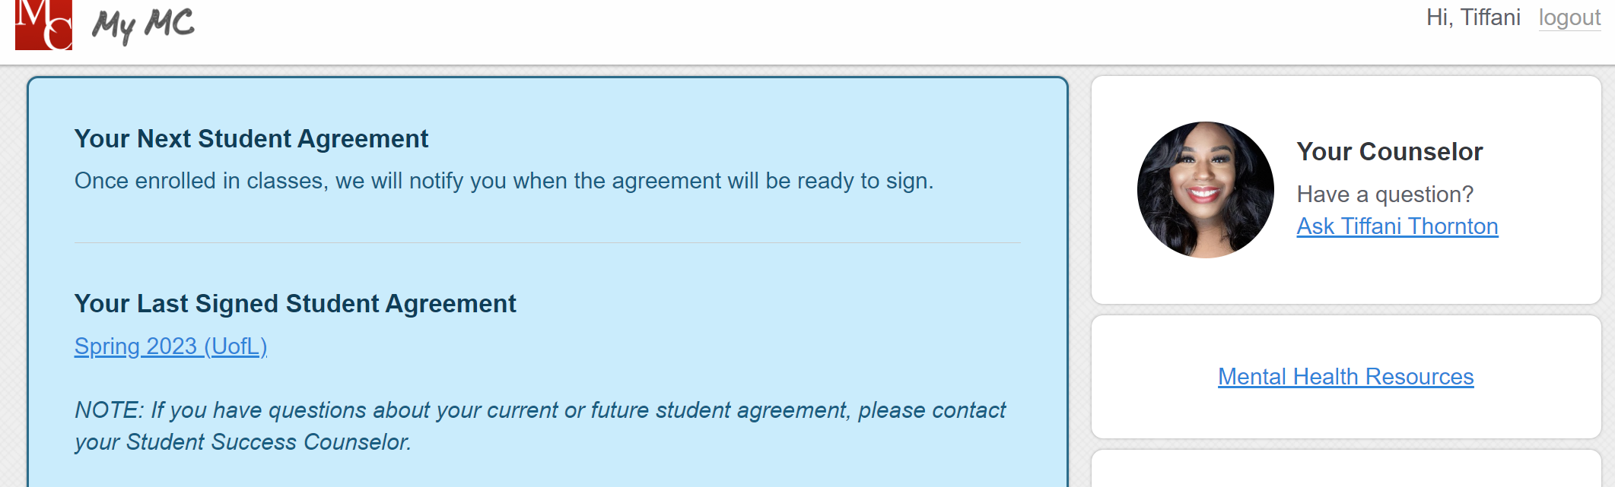

1. If your box is color **“Yellow”** you have barrier/s preventing you from signing your agreement.

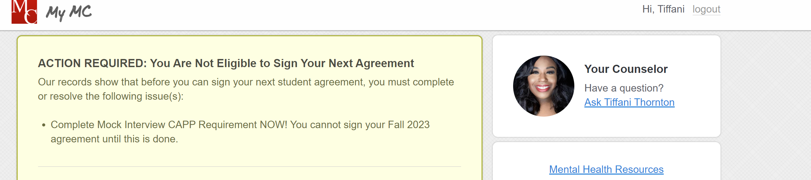

1. A **“Green”** box indicates that your agreement for the upcoming semester is ready for you to sign and review.

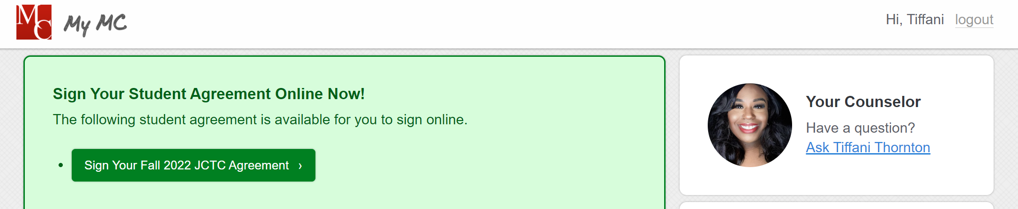

1. If you have any questions or concerns, please contact your counselor.