# **JCTC Holds Removal Instructions**

**How to determine if you have any holds for the upcoming semester:**

1. Login to MyPath and Click on Student Self-Service Center
2. Click on Student Center

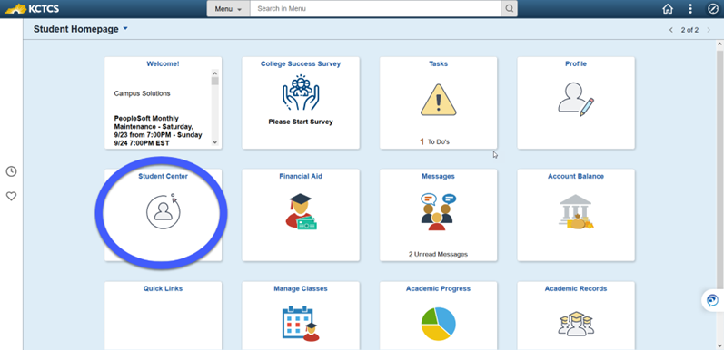

1. Look on the right side of your screen for “Holds”

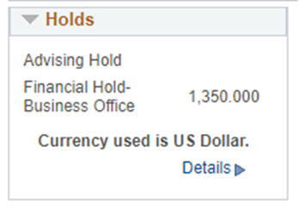

1. Click on Details to see further details about your hold

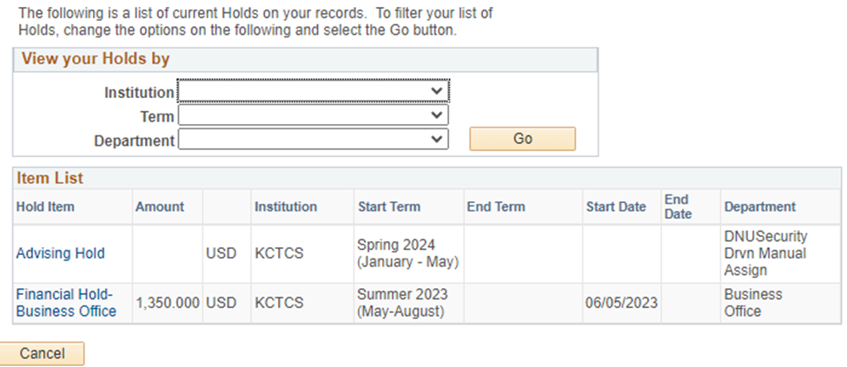

1. Contact your Metro advisor for information about how to remove your holds or click on the blue hold under “Hold Item.” This should tell you which office your hold is located in.